Grade 7 Accelerated · Unit 3 · Lesson 5  Applying Exponent Laws  Independent Set 3.05 | Name______________________  Date______________________  Period____________________

Six questions, on your own, in silence. Show the step that does the work.
1. Rewrite with a positive exponent. 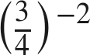

2. Find the value. 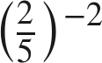

3. Rewrite with a positive exponent. 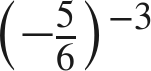

4. Find the value. 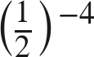

5. Find the value. 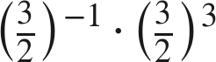

6. Find the value of . 